Денис Дубинин, 28 -когорта - 1 спринт

**Часть 1**

1. Mindmap:

https://miro.com/app/board/o9J_lhPZVtk=/

https://docs.google.com/spreadsheets/d/1jJRG_VBGbfESXTuSEVlJipQclQn5gslbDvhdlc8bY0E/edit?usp=sharing

**Часть 2**

1. Блок-схема:

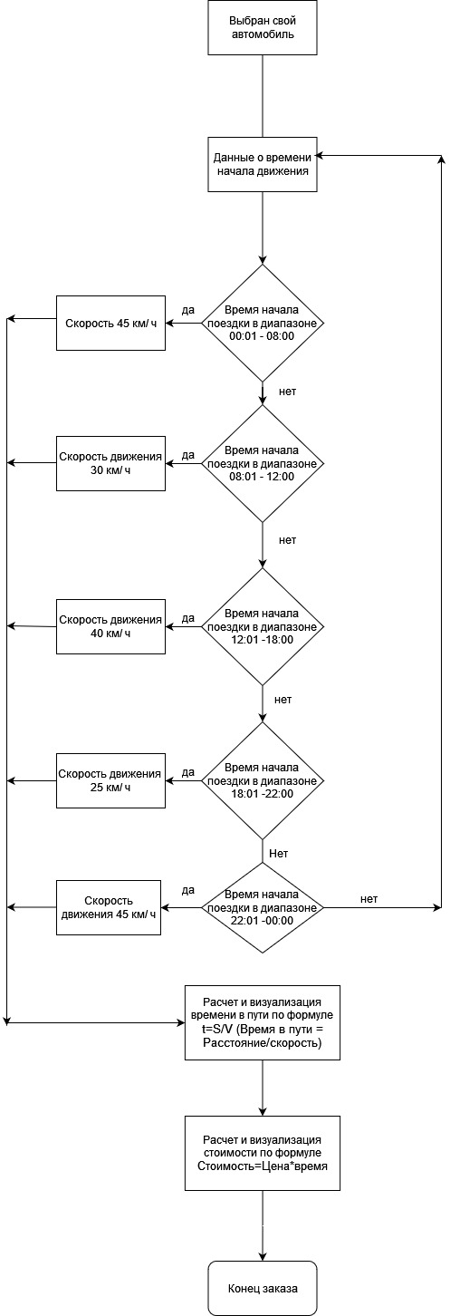

https://docs.google.com/spreadsheets/d/1jJRG_VBGbfESXTuSEVlJipQclQn5gslbDvhdlc8bY0E/edit?usp=sharing